Project Design Phase-II
Combined Design Document
Script-Controlled ACL – Restrict Record Access Based on Field Value
Team Member | Role
Afrin Fathima S | Team Lead
Adhithan S | Team Member
Abhishek Raja | Team Member
Ajith Kumar S S | Team Member

Date: 31 January 2025
Team ID: To be filled by the team
Maximum Marks: 4 Marks (each part)

Contents
- Customer Journey Map
- Data Flow Diagram & User Stories
- Solution Requirements (Functional & Non-functional)
- Technology Stack (Architecture & Stack)

Customer Journey Map
Script-Controlled ACL – Restrict Record Access Based on Field Value
SCENARIO | Requesting, viewing and administering records protected by a script-controlled ACL that restricts access based on a field value (e.g., Incident records limited by the Department field)
Prepared by | Afrin Fathima S (Team Lead), Adhithan S, Abhishek Raja, Ajith Kumar S S
Basis | The team’s analysis of the expected user experience in the ServiceNow platform. No customer interviews were conducted.

Entice
How does someone initially become aware of this process?
 | Step 1 | Step 2 | Step 3 | Step 4
Steps  What does the person (or group) typically experience? | Sensitive data identified  The data owner or security manager sees that some records (e.g., Incidents) must be visible only when a field value matches. | Log in to the instance  The user signs in to the ServiceNow instance from a web browser or the mobile app. | Open a table list  The user opens the Incident list or a record form to look up the records they need. | Notice the restricted view  The user sees only some records; the list reports that rows were removed by security constraints.
Interactions  What interactions do they have at each step along the way?  People: Who do they see or talk to?  Places: Where are they?  Things: What digital touchpoints or physical objects would they use? | People: Data owner, Administrator  Places: Planning meeting, email  Things: Security policy, ticket | People: Employee, Fulfiller  Places: Web browser, Now Mobile app  Things: Login page, SSO | People: None (self-service)  Places: Incident list in the instance  Things: Filter navigator, list view | People: Service desk (if the user asks)  Places: List or form view  Things: “rows removed by security constraints” message
Goals & motivations  At each step, what is a person’s primary goal or motivation? (“Help me...” or “Help me avoid...”) | Help me protect sensitive records without hiding the whole table. | Help me sign in quickly and reach my work. | Help me find the records I need to work on. | Help me understand why some records are not shown.
Positive moments  What steps does a typical person find enjoyable, productive, fun, motivating, delightful, or exciting? | A clear business reason makes the rule easy to define. | Single sign-in gives quick access. | Lists show only relevant records, which reduces clutter. | Users can see that sensitive data is protected.
Negative moments  What steps does a typical person find frustrating, confusing, angering, costly, or time-consuming? | Rule conditions can be ambiguous (which field, which users). | Wrong role or department data blocks valid access. | A short or empty list can look like a bug. | Users are unsure whether records are missing or hidden.
Areas of opportunity  How might we make each step better? What ideas do we have? What have others suggested? | How might we capture the rule as a simple table of field value vs. allowed users before coding? | Could we validate department and role data automatically at login? | Could we show a short banner saying the list is filtered by policy? | How might we give a friendly explanation and a link to request access?

Enter
What do people experience as they begin the process?
 | Step 1 | Step 2 | Step 3 | Step 4
Steps  What does the person (or group) typically experience? | Elevate privileges  The Administrator elevates to the security_admin role to create or edit an ACL. | Create the ACL  Define the table, the operation (read) and the field that controls access (e.g., Department). | Write the ACL script  Add a server-side script that compares the record’s field value with the user’s attribute and returns true or false. | Activate and set roles  Save and activate the rule and set the roles that may bypass the check.
Interactions  What interactions do they have at each step along the way?  People: Who do they see or talk to?  Places: Where are they?  Things: What digital touchpoints or physical objects would they use? | People: Administrator  Places: User menu in the instance  Things: Elevate Role dialog | People: Administrator  Places: System Security > Access Control (ACL)  Things: ACL form (type, operation, name) | People: Administrator, developer  Places: Script field of the ACL  Things: Server-side JavaScript, GlideSystem, GlideRecord | People: Administrator, security manager  Places: ACL record, Roles related list  Things: Active checkbox, roles list
Goals & motivations  At each step, what is a person’s primary goal or motivation? (“Help me...” or “Help me avoid...”) | Help me get safe, temporary rights to change security settings. | Help me target exactly the right table and field. | Help me write a rule that is correct and quick. | Help me turn the rule on without breaking existing access.
Positive moments  What steps does a typical person find enjoyable, productive, fun, motivating, delightful, or exciting? | Elevation protects security settings from accidental change. | The ACL form gives structured fields for table and operation. | A script gives full control over the field-value condition. | Role bypass keeps administrators able to support users.
Negative moments  What steps does a typical person find frustrating, confusing, angering, costly, or time-consuming? | The extra step slows urgent changes. | A wrong table or field name makes the rule ineffective. | Syntax errors or slow queries can lock users out or slow lists. | Activating without testing risks wrong access.
Areas of opportunity  How might we make each step better? What ideas do we have? What have others suggested? | How might we remind administrators to drop the elevated role after changes? | Could we provide a naming checklist for ACLs? | Could we offer a reusable script include for the field-value check? | How might we test the rule in a sub-production instance first?

Engage
In the core moments in the process, what happens?
 | Step 1 | Step 2 | Step 3 | Step 4
Steps  What does the person (or group) typically experience? | Open a matching record  A user whose attribute matches the field value opens a record. | Open a non-matching record  A user tries to reach a restricted record through a list, search, report or direct link. | ACL script evaluates  The platform runs the script, compares the field value with the user’s attribute and returns allow or deny. | Access granted or denied  The record is shown or hidden; denied users see a security-constraint message.
Interactions  What interactions do they have at each step along the way?  People: Who do they see or talk to?  Places: Where are they?  Things: What digital touchpoints or physical objects would they use? | People: Employee, Fulfiller  Places: Record form  Things: Incident form, related lists | People: Employee from another department  Places: List, global search, record URL  Things: Browser URL, search box, report | People: None (system)  Places: Server-side ACL engine  Things: ACL script, GlideRecord, Debug Security Rules | People: The user  Places: Form or list  Things: “Security constraints prevent access” page
Goals & motivations  At each step, what is a person’s primary goal or motivation? (“Help me...” or “Help me avoid...”) | Help me see and update my records without friction. | Help me know why I cannot view this record. | Help the system decide correctly and quickly. | Help me feel confident that data is protected and know what to do next.
Positive moments  What steps does a typical person find enjoyable, productive, fun, motivating, delightful, or exciting? | Matching users work normally with no extra steps. | Restricted records stay hidden in every view (list, search, API). | The decision is the same for every access path. | The outcome is clear: allowed or denied.
Negative moments  What steps does a typical person find frustrating, confusing, angering, costly, or time-consuming? | Wrong user data can deny a valid user. | Users may try repeated links or searches for hidden records. | Heavy scripts slow down list loading. | A generic denial message gives no guidance.
Areas of opportunity  How might we make each step better? What ideas do we have? What have others suggested? | Could we sync department data automatically from the HR source? | How might we log repeated attempts for review? | Could we use simple, indexed field checks and avoid queries inside the script? | How might we show a custom message with a request-access link?

Exit
What do people typically experience as the process finishes?
 | Step 1 | Step 2 | Step 3 | Step 4
Steps  What does the person (or group) typically experience? | Finish work and sign out  The authorised user completes updates and leaves the session. | Raise an access request  A denied user asks for access to a record they need. | Review the request  A manager or administrator approves or declines, or corrects the user’s attribute or role. | Check the audit trail  A security administrator checks the logs to confirm the rule was enforced.
Interactions  What interactions do they have at each step along the way?  People: Who do they see or talk to?  Places: Where are they?  Things: What digital touchpoints or physical objects would they use? | People: Employee, Fulfiller  Places: Web or mobile app  Things: Log out, session end | People: Employee, Service desk  Places: Service Portal or incident form  Things: Access request form | People: Manager, Administrator  Places: Approval list, user record  Things: Approval, role list | People: Administrator, Auditor  Places: System Logs, Debug Security Rules  Things: Log entries, reports
Goals & motivations  At each step, what is a person’s primary goal or motivation? (“Help me...” or “Help me avoid...”) | Help me leave knowing my changes were saved. | Help me ask for access without confusion. | Help me decide quickly and safely. | Help me prove that the restriction worked.
Positive moments  What steps does a typical person find enjoyable, productive, fun, motivating, delightful, or exciting? | Work is saved and the session ends safely. | One request path replaces ad-hoc emails. | Approval keeps accountability. | Logs give evidence for audits.
Negative moments  What steps does a typical person find frustrating, confusing, angering, costly, or time-consuming? | Unsaved changes can be lost if the session times out. | Users may not know what to put in the request. | Slow approvals delay work. | Logs can be hard to read.
Areas of opportunity  How might we make each step better? What ideas do we have? What have others suggested? | Could we warn users about unsaved changes before sign-out? | Could we pre-fill the request with the record number and field value? | How might we add reminders and escalation for pending approvals? | How might we offer a simple report of denied access?

Extend
What happens after the experience is over?
 | Step 1 | Step 2 | Step 3 | Step 4
Steps  What does the person (or group) typically experience? | Test with impersonation  The Administrator impersonates sample users to confirm what each one can see. | Check reports and APIs  Verify that reports, dashboards and REST calls return only permitted records. | Extend the rule  Apply the same pattern to other tables or fields. | Periodic review  Review rules, roles and feedback and improve them.
Interactions  What interactions do they have at each step along the way?  People: Who do they see or talk to?  Places: Where are they?  Things: What digital touchpoints or physical objects would they use? | People: Administrator, tester  Places: Impersonate User option  Things: Test users, test records | People: Managers, Analysts  Places: Reports, dashboards, Table API  Things: Report, Postman | People: Administrator, developer  Places: ACL list  Things: Copied ACL, script include | People: Security manager, team  Places: Review meeting  Things: Access review, audit report
Goals & motivations  At each step, what is a person’s primary goal or motivation? (“Help me...” or “Help me avoid...”) | Help me confirm that each type of user sees the right data. | Help me trust that no data leaks through other paths. | Help me reuse what works. | Help me keep the rule correct as the organisation changes.
Positive moments  What steps does a typical person find enjoyable, productive, fun, motivating, delightful, or exciting? | Impersonation tests without sharing passwords. | The same ACL protects every access path. | A reusable pattern saves time. | Reviews keep access up to date.
Negative moments  What steps does a typical person find frustrating, confusing, angering, costly, or time-consuming? | Many test cases are needed. | Some paths (e.g., integrations) may need extra checks. | Copying scripts can spread mistakes. | Reviews are easy to forget.
Areas of opportunity  How might we make each step better? What ideas do we have? What have others suggested? | Could we build a standard test matrix of users vs. records? | Could we add automated tests with the Automated Test Framework? | How might we move the logic into one shared script include? | Could we schedule recurring access-review tasks?

Project Design Phase-II
Data Flow Diagram & User Stories
Date | 31 January 2025
Team ID
Project Name | Script-Controlled ACL – Restrict Record Access Based on Field Value
Maximum Marks | 4 Marks

Data Flow Diagrams:

A Data Flow Diagram (DFD) is a traditional visual representation of the information flows within a system. A neat and clear DFD can depict the right amount of the system requirement graphically. It shows how data enters and leaves the system, what changes the information, and where data is stored.

For this project, the DFD shows how a user request for a record is checked by a script-controlled ACL that compares a field value on the record with an attribute of the user (for example, the Department field) before any data is returned.
DFD Level 0
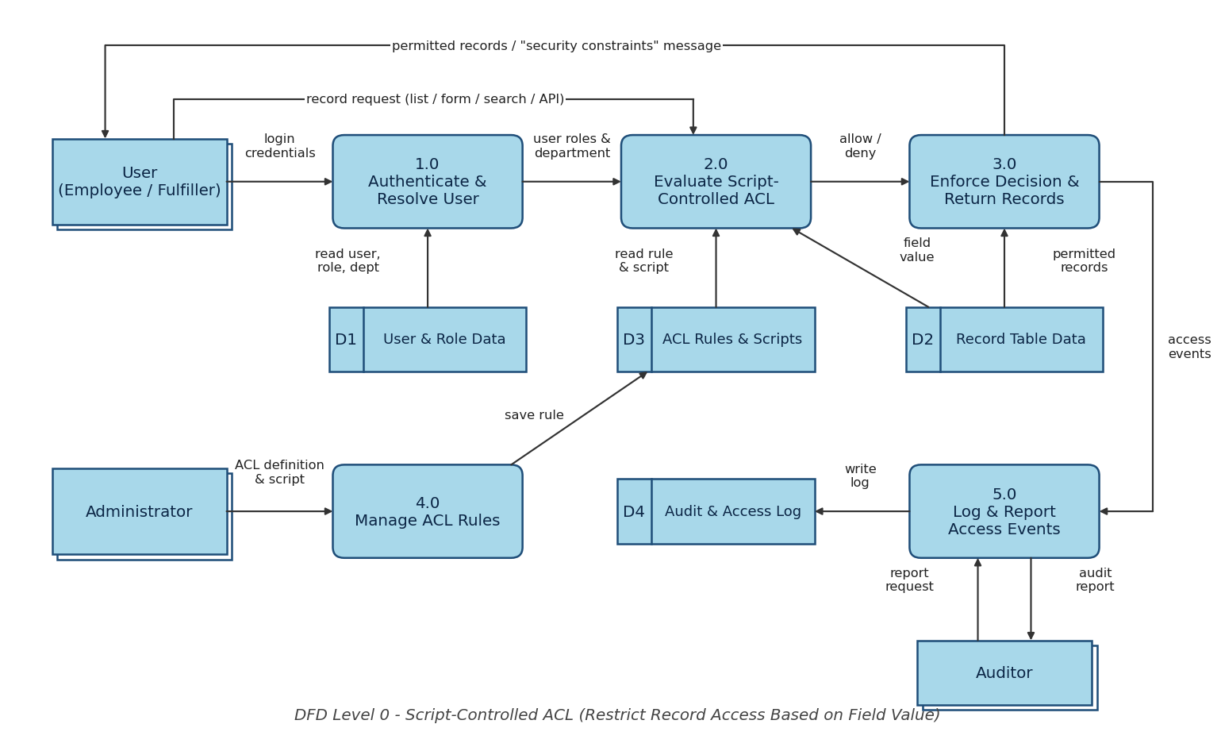

Flow

- The user logs in to the web portal or mobile app (process 1.0), which reads the user, role and department from the User & Role data (D1).

- The user opens a list, form, search or API call for a record; the request goes to the ACL evaluation (process 2.0) together with the user’s roles and department.

- Process 2.0 reads the ACL rule and its script from the ACL Rules store (D3) and the field value of the record from the Record Table (D2).

- The script returns allow or deny: administrators and security roles are allowed, and other users are allowed only when the field value matches their attribute.

- Process 3.0 enforces the decision: permitted records are returned, restricted records are hidden or a “security constraints” message is shown.

- Every access event is passed to process 5.0, which writes the audit and access log (D4) and produces reports for the Auditor.

- The Administrator defines and maintains the ACL and its script through process 4.0, which saves them in the ACL Rules store (D3).
User Stories
Use the below template to list all the user stories for the product.
User Type | Functional Requirement (Epic) | User Story Number | User Story / Task | Acceptance criteria | Priority | Release
Employee (Mobile user) | Login & Role Resolution | USN-1 | As a mobile user, I can log in to the mobile app with my username and password (or SSO). | I can log in and reach my home screen. | High | Sprint-1
 | Record Access Enforcement | USN-2 | As a mobile user, I can open a record list in the mobile app and see only the records whose field value matches my department. | Records that do not match are not listed and cannot be opened. | High | Sprint-2
Employee (Web user) | Login & Role Resolution | USN-3 | As a web user, I can log in through the web UI / Service Portal with my credentials or SSO. | I can log in and reach my dashboard. | High | Sprint-1
 | Record Access Enforcement | USN-4 | As a web user, I can open lists and forms and see only the records allowed by the field-value rule. | Allowed records open normally; others are hidden from lists, search and reports. | High | Sprint-2
 |  | USN-5 | As a web user, when I open a restricted record by direct link, I see a clear security message instead of the data. | No restricted field values are shown; the access-denied page appears. | High | Sprint-2
 | Access Request & Review | USN-6 | As a web user, I can raise a request for access to a record I cannot see. | A request is created with the record number and I receive a confirmation. | Medium | Sprint-3
Service Desk Agent (Fulfiller) | Record Access Enforcement | USN-7 | As a fulfiller, I can view and update the records whose field value matches my department or assignment. | I can open and save matching records. | High | Sprint-2
 |  | USN-8 | As a fulfiller, I do not see restricted records in related lists, global search or reports. | Restricted records are absent in all these views. | Medium | Sprint-2
Department Manager | Access Request & Review | USN-9 | As a manager, I can approve or decline a request for access to a restricted record. | The requester is notified of the decision. | Medium | Sprint-3
Administrator | ACL Configuration | USN-10 | As an administrator, I can create a read ACL on a table (e.g., Incident) that is controlled by a field value. | The ACL is saved for the correct table, field and operation. | High | Sprint-1
 |  | USN-11 | As an administrator, I can write a server-side ACL script that compares the record’s field value with the user’s attribute. | The script returns true only when the values match. | High | Sprint-1
 |  | USN-12 | As an administrator, I can allow admin and security roles to bypass the field-value check. | Users with these roles can open all records. | Medium | Sprint-2
 |  | USN-13 | As an administrator, I can test the rule by impersonating sample users. | Each test user sees only the records they should see. | High | Sprint-2
 |  | USN-14 | As an administrator, I can activate or deactivate the rule without changing the data. | Switching the rule off restores the earlier access; switching it on applies the restriction. | Medium | Sprint-3
Auditor | Audit & Monitoring | USN-15 | As an auditor, I can review the log of denied access attempts. | The log shows the user, the record and the time. | Medium | Sprint-3
 |  | USN-16 | As an auditor, I can view a report of the records restricted by the field-value rule. | The report lists the restricted records and the field value used. | Low | Sprint-3

Project Design Phase-II
Solution Requirements (Functional & Non-functional)
Date | 31 January 2025
Team ID
Project Name | Script-Controlled ACL – Restrict Record Access Based on Field Value
Maximum Marks | 4 Marks
Functional Requirements:
Following are the functional requirements of the proposed solution.
FR No. | Functional Requirement (Epic) | Sub Requirement (Story / Sub-Task)
FR-1 | User Login & Role Resolution | Login through username and password  Login through SSO (SAML 2.0)  Retrieval of the user’s roles and department after login
FR-2 | ACL Rule Definition | Creation of a record-level read ACL on the target table  Server-side script that compares the record’s field value with the user’s attribute  Role bypass for administrator and security roles  Activation and deactivation of the rule
FR-3 | Record Access Enforcement | Restricted records hidden in lists, forms and related lists  Restricted records blocked in direct links, global search and reports  Same rule enforced for REST Table API calls
FR-4 | Access Request & Approval | Raising an access request for a restricted record  Approval or rejection by the manager with notification
FR-5 | Audit & Monitoring | Writing access-denied events from the ACL script to the system log  Report of restricted records and access attempts
Non-functional Requirements:
Following are the non-functional requirements of the proposed solution.
FR No. | Non-Functional Requirement | Description
NFR-1 | Usability | Users see a clear message when access is denied. Lists and forms work the same on the web UI and the mobile app. The ACL form is simple for administrators to maintain.
NFR-2 | Security | The rule is enforced on the server, never only in the browser. If the script fails or a value is missing, access is denied by default. Only users with the security_admin role can change ACLs. Messages do not reveal restricted field values. All access uses HTTPS.
NFR-3 | Reliability | The script handles empty field values and missing user attributes without errors and gives the same decision every time. Changes are tested with impersonation before the rule is activated.
NFR-4 | Performance | The script uses only simple field comparisons and avoids extra database queries, so list and form loading is not noticeably slower than before the rule.
NFR-5 | Availability | The rule runs inside the ServiceNow platform, so it is available whenever the instance is available. No separate service is needed.
NFR-6 | Scalability | The rule is driven by field values and user attributes, so new departments or values need no code change. The same pattern can be reused on other tables.

Project Design Phase-II
Technology Stack (Architecture & Stack)
Date | 31 January 2025
Team ID
Project Name | Script-Controlled ACL – Restrict Record Access Based on Field Value
Maximum Marks | 4 Marks
Technical Architecture:
The Deliverable shall include the architectural diagram as below and the information as per the table1 & table 2.
Example: Script-controlled record access in a ServiceNow instance, restricted by a field value.
Guidelines covered in the diagram:
- All processes are included as application logic blocks (authentication and role resolution, ACL script engine, access request workflow, audit log).
- Infrastructural demarcation is shown (Local: user devices; Cloud: ServiceNow instance).
- External interfaces are indicated (SSO identity provider, REST API clients).
- Data storage components are indicated (platform database, attachments).
- Interface to machine learning models: not applicable.

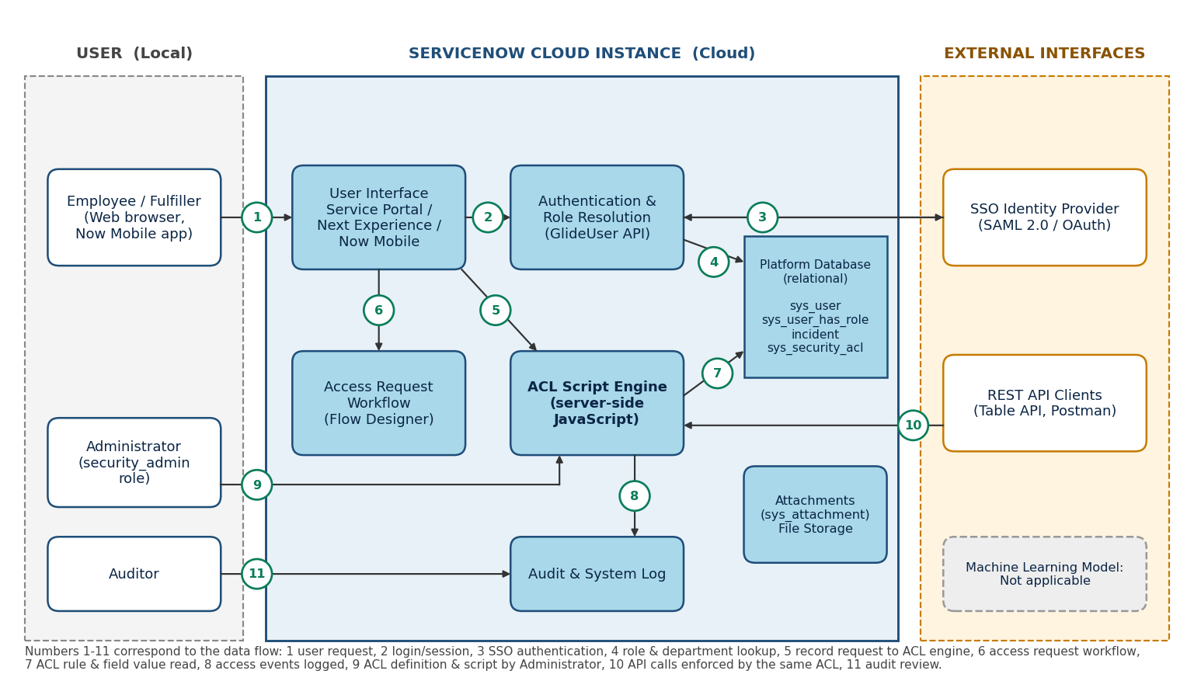

Table-1 : Components & Technologies:
S.No | Component | Description | Technology
1. | User Interface | How the user interacts with the application: web UI and mobile app for viewing records and raising access requests | HTML, CSS, JavaScript, AngularJS (Service Portal), Now Mobile app
2. | Application Logic-1 | ACL script that compares the record’s field value with the user’s attribute and returns allow or deny | Server-side JavaScript (GlideSystem, GlideRecord)
3. | Application Logic-2 | Authentication and role resolution: gets the logged-in user’s roles and department | GlideUser API, SSO login
4. | Application Logic-3 | Access request and approval process for restricted records | ServiceNow Flow Designer
5. | Database | Data type, configuration: tables such as sys_user, sys_user_has_role, incident and sys_security_acl | ServiceNow platform relational database (accessed through GlideRecord)
6. | Cloud Database | Database service on the cloud: the ServiceNow instance stores all application data | ServiceNow cloud instance (Personal Developer Instance)
7. | File Storage | File storage requirements: attachments on records | ServiceNow attachments (sys_attachment)
8. | External API-1 | Single sign-on for authenticating users | SSO identity provider using SAML 2.0 (optional)
9. | External API-2 | Access to records by external applications, with the same ACL enforced | ServiceNow REST Table API (tested with Postman)
10. | Machine Learning Model | Purpose of machine learning model | Not applicable for this solution
11. | Infrastructure (Server / Cloud) | Application deployment on local system / cloud | Cloud: ServiceNow instance hosted by ServiceNow

Local Server Configuration: Not required. Users reach the application through a web browser or the Now Mobile app.
Cloud Server Configuration: ServiceNow instance hosted by ServiceNow (Personal Developer Instance for development and testing).

Table-2: Application Characteristics:
S.No | Characteristics | Description | Technology
1. | Open-Source Frameworks | Open-source frameworks used on the portal and for testing | AngularJS, Bootstrap (Service Portal), Postman (API testing)
2. | Security Implementations | Security and access controls: script-controlled ACL, role-based access, elevation to security_admin for ACL changes, default deny, HTTPS | ACL scripts, roles, IAM through SSO, TLS
3. | Scalable Architecture | Multi-tier platform (client, application server, database); the rule is attribute-driven and reusable on other tables | ServiceNow multi-tier cloud platform
4. | Availability | The rule is part of the ServiceNow platform, so its availability follows the platform’s hosting and failover | ServiceNow cloud hosting
5. | Performance | Simple field comparisons in the script, no extra queries inside the ACL, and indexed fields for the controlling value | Optimised ACL script, indexed fields
References:
- https://c4model.com/
- https://developer.ibm.com/patterns/online-order-processing-system-during-pandemic/
- https://www.ibm.com/cloud/architecture
- https://aws.amazon.com/architecture
- https://medium.com/the-internal-startup/how-to-draw-useful-technical-architecture-diagrams-2d20c9fda90d

